**REACT CYCLE DIAGRAM**

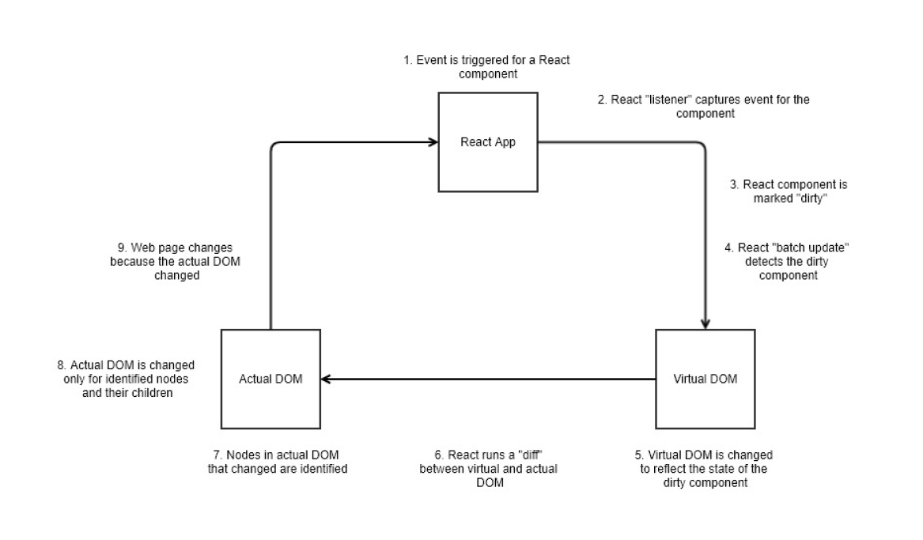

**MORE ON COMPONENTS**

In React, components are JavaScript functions or classes that can accept input.

Inputs (information that is entered) are referred to as properties. React abbreviates properties as “props”.

As a result of accepting input, components can return React elements that specify how user interfaces should appear.

**COMMAND LINE**

You can utilize the command line to run package managers.

As a reminder: here are a couple resources for accessing the command line from VS Code:

1. Integrated Terminal in Visual Studio Code:

[**https://code.visualstudio.com/docs/editor/integrated-terminal**](https://code.visualstudio.com/docs/editor/integrated-terminal)

2. Command Line Interface (CLI)

[**https://code.visualstudio.com/docs/editor/command-line**](https://code.visualstudio.com/docs/editor/command-line)